Language Arts

Kevin Gilds, MPA

2016-07-23

# Reading Improvement:

## Objective:

*50% of participating students will improve their reading skills as demonstrated by their Language Arts grade increasing or maintaining a "C" grade from the baseline grading period to the final grading period as evidenced by report cards/school reports.*

### Language Arts Grade: % of Students that increased Grade or maintained a C

The number of students that could be matched from baseline to final is **543**

Success is defined by students who increased their grade and finished with a C or higher and students who maintained a grade. A student who improves from a F to D is not considered a success for the purpose of this analysis. Students who went from a A to B is not considered a success for this analysis.

The percent of students with the successful outcome is **82.32%**.

1. The number of students who increased their Language Arts Grade with a final grade of at least a C is: **196**
2. The number of students who maintained their baseline grade with at least a C: **251**
3. The percent of students who had a failing grade at basline and finished with a passing final grade is **15.29%**

The mean difference betwween baseline grades and final grade ***0.2689***.

### Grade Change Plot from baseline to fina grading period:

The changes in grades from baseline to final grading period is represented below. The vertical axis represents baseline grades and the bottom axis the change from the baseline. Thus ideally we want to see circles moving to right. Note that,students with an A in Q1 can decrease but not increase.

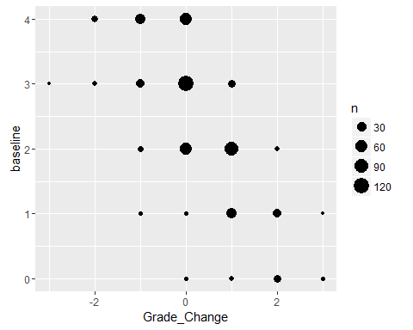

### Statistical Tests

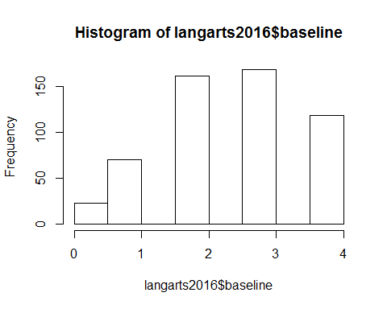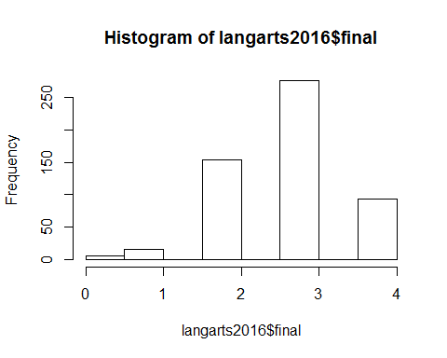

##   
## Paired t-test  
##   
## data: langarts2016$baseline and langarts2016$final  
## t = -6.8402, df = 542, p-value = 1.071e-11  
## alternative hypothesis: true difference in means is less than 0  
## 95 percent confidence interval:  
## -Inf -0.2041096  
## sample estimates:  
## mean of the differences   
## -0.2688766

##   
## Cohen's d  
##   
## d estimate: -0.2935413 (small)  
## 95 percent confidence interval:  
## inf sup   
## -0.4133750 -0.1737075